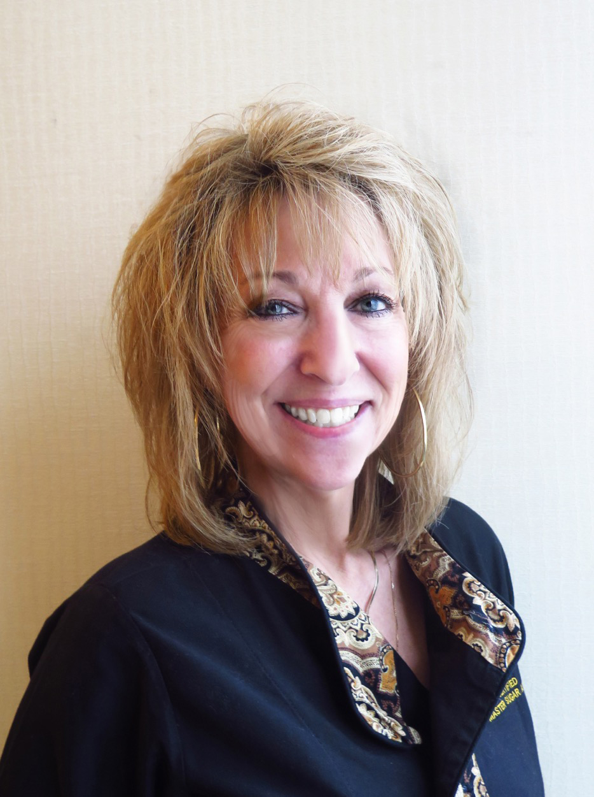
Peggy Tucker is an award winning Certified Master Sugar Artist, one of only 32 in the world and is internationally known. She teaches, demonstrates and judges all over the world and is the owner of School of Cakeology, which is a mobile classroom specializing in cake design, decorating, and the art of sugar, all brought to you. She also owns CakePlay Inc

Even though she is now the owner of CakePlay Inc. she continues to share her love and passion of the sugar arts by teaching classes, judging competitions, volunteered at multiple charity events, culinary schools and collaborated with companies to develop and bring new products to the market.

Peggy was named as one of Dessert Professional’s Top Ten Cake Artists of North America in 2014, in 2016 was awarded the Sweet Life Award and then in 2018 was awarded the ICES Hall of Fame award. She has appeared on The Food Network and Fox News, and has written articles published in American Cake Decorating Magazine, Edible Artist Network Magazine, Cakes and Crafts Magazine and ICES Magazine.

